***Analyzing network traffic file***

Guilherme S. Mazzariol

Bachelor of Science in Computer Science

Campinas/SP - Brazil

g138466@g.unicamp.br

# **I. Introduction**

Using Wireshark program, it is possible to read a lot of information about traffic in a network on the fly, or from a capture file (*.pcap). Besides Wireshark, tshark[1] is another tool used to read traffic in a network, listening to what is happening in it. This paper uses those programs to read traffic from file *traffic1.pcap* and get more information about it.

1. **Discovering the involved Systems and their Geographical Location**

Using tshark command:

***tshark -r traffic1.pcap -qnz ip_hosts,tree***

We can figure the IP address in the *traffic1.pcap* file:

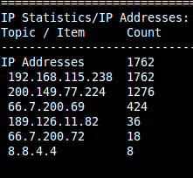

Some operational systems have, in their packets, a specific TTL and Windows Size, as shown in this table [2]:

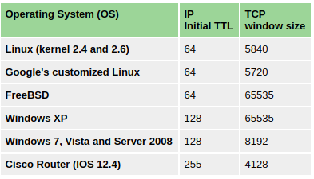

So, comparing the information from each packet in Wireshark to the information on the table, we can say which is the Operating System from each IP:

192.168.115.238 - Windows XP:



200.149.77.224 - FreeBSD:



66.7.200.69 - Linux:



66.7.200.72 - FreeBSD:



189.126.11.82 - Linux:



To know where are geographically located the attacking hosts, it’s necessary to import and enable GeopIp on Wireshark. All database used for GeopIp was downloaded from MaxMind Developer Site [3].

Using this information, it was possible to identify the locations of hosts:

192.168.115.238

*Local IP - Not possible to Locate*

200.149.77.224 - Brazil:



66.7.200.69 - United States:



66.7.200.72 - United States:



189.126.11.82 - Brazil:



1. **Identifying the TCP Sessions**

To show the TCP sessions, you just need to access Wireshark Expert Info (*Wireshark >> Analyze >> Expert Info*). This tool gives us a resume of what is happening in the TCP sessions:

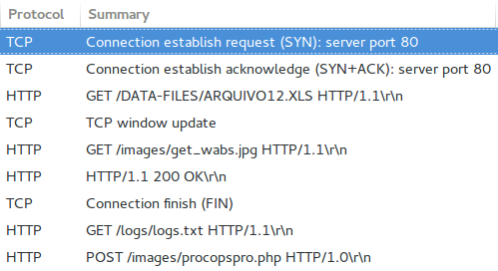

Counting the rows, it is possible to identify 9 TCP sessions in the *traffic1.pcap* file. To save each TCP session in a file to analyze the actions in sessions, it was used a specific filter in Wireshark:

*tcp.stream eq $Number*

where *$Number* must be replaced by the session number (0,1,2,...,8).

1. **Analyzing the attack**

By now, we know that there are 9 TCP sessions in the *traffic1.pcap* file, but it’s interesting to know how much time each session took, to identify more information about what is happening in that specific attack. To do that, we used the Wireshark Statistics (*Wireshark >> Statistics >> Conversions >> TCP*), that gives us the time per session:

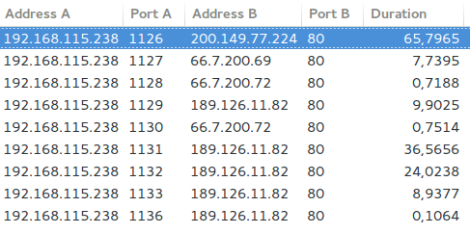

With this information, we can look for the session from IP 192.168.115.238 and 200.149.77.224 which took longer compared to all other sessions: 65,7965 seconds. This is probably the attack session, if we think only about time. But it is necessary to take a look in TCP sessions.

Session 3 has a HTTP GET request, so look deeper in this session. Putting protocols in order by name, we can find that:

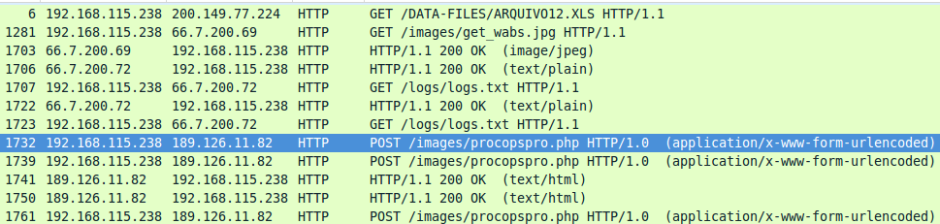

Two POST requests (packets 1732 and 1739, in order) so, looking further into these packets with Wireshark:

Packet 1281 gets file ***get_wabs.jpg***

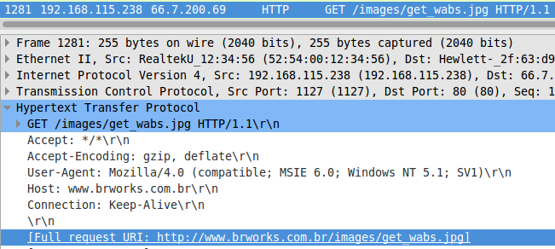

Searching for this file in web, we found a web page Remove get_wabs[1].jpg [4] that said get_wabs.jpg is able to detect system vulnerabilities and then lead off an attack. So the attack starts here.

Packet 1707 gets the file ***http://brdotcom.com.br/logs/logs.txt***

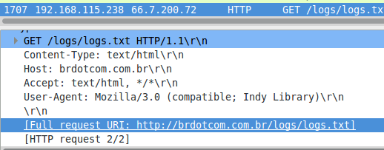

Searching for this file in web, we found the page “*How to Remove Win32.TrojanSpy.Bancos*” [6] telling about a trojan downloading that file, so attack continues.

Packet 1732 has the file ***emplite.exe***

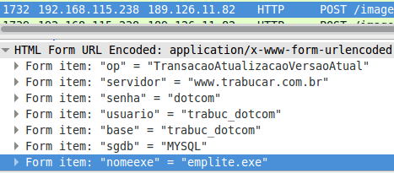

Packet 1739 has the file ***mdlplite.exe***

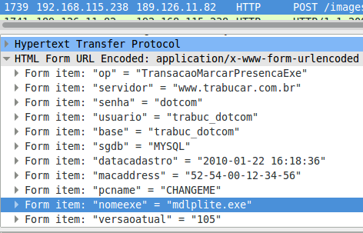

Searching online for the files *emplite.exe* and *mdlplite.exe*, we found a page from trend micro telling about the “*TROJ_THINSTAL.RN - Threat Encyclopedia - Trend Micro AU*” [7]. In that point we found the proof that the attack involved the malware ***“TROJ_THINSTAL.RN”***.

Looking further, we found that:

Packet 1761 has the file procopspro.php

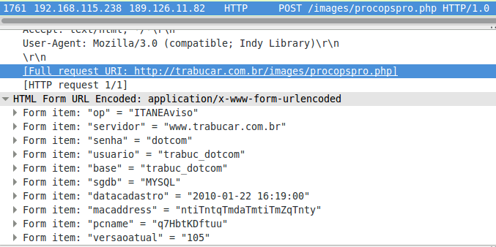

Searching in web for that file we found a page from trend micro: ***“TROJ_BANKER.LMQ - Threat Encyclopedia - Trend Micro US”***[8], saying:

“This Trojan monitors the Internet Explorer (IE) activities of the affected system, specifically the address bar. It recreates a legitimate Web site with a spoofed login page if a user visits banking sites with certain strings in the address bar.”

At this point we can find the trojan: he was spoofing the page from some banks in victims machines.

**The packet 1761 identifies the attacker who has the IP 189.126.11.82 locating in Brazil.**

The attack starts on packet 1281 and ends on packet 1761, so if we search for this packets on TCP sessions, we find packet 1281 in session 4, packet 1707 in session 7 and packets 1732-1739-1761 in session 8, so the time spent on attacks was the sum of the time from each session, totalizing 9,7955 seconds.

##### **References**

[1] tshark(1) - Linux man page, <https://linux.die.net/man/1/tshark>

[2] Passive OS Fingerprinting - NETRESEC Blog <http://www.netresec.com/?page=Blog&month=2011-11&post=Passive-OS-Fingerprinting>

[3] GeoLite Legacy Downloadable Databases, MaxMind Developer Site, <http://dev.maxmind.com/geoip/legacy/geolite/>

[4] Remove get_wabs[1].jpg <http://www.completelyuninstallprogram.com/get-wabs-1-jpg/>

[5] Analysis #totalhash , <https://totalhash.cymru.com/analysis/?4dfe09415724bac695735af2b85b443cae69ebfd>

[6] How to Remove Win32.TrojanSpy.Bancos, <https://www.securitystronghold.com/gates/win32.trojanspy.bancos.html>

[7] “TROJ_THINSTAL.RN - Threat Encyclopedia - Trend Micro AU”, <https://www.trendmicro.com/vinfo/au/threat-encyclopedia/malware/troj_thinstal.rn>

[8] “TROJ_BANKER.LMQ - Threat Encyclopedia - Trend Micro US”, https://www.trendmicro.com/vinfo/us/threat-encyclopedia/archive/malware/troj_banker.lmq